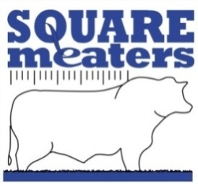
Square Meaters Cattle Association of
Australia Ltd
A.B.N. 87 681 797 865
SQUARE MEATERS SUMMER SHOW UNIFORM ORDER FORM

Please select the size you require and forward the form along with sufficient funds to:
Square meaters Cattle Association of Australia via fax, email or snail mail. Payment for shirts to be sent via cheque to the SMCAA office or direct debit to:
Bank Westpac
BSB 032273
Account number 276420

Name: ---------------------------------------------------------------------------------------
Address __________________________________________________________________________________________________________________________________________________________________
Telephone _______________________ Email _____________________________________________
Size Ladies _____________________ ___________________________
Men’s _______________________ ___________________________
Total number of shirts ordered_________________
Cost $59.99 inclusive of GST plus $12 postage and handling.

All shirts will be sent directly from the supplier to your mailing address so please ensure all mailing details are completed.

